S_ALR_87013181 -

Functionality

This report is useful in the analysis of material ledger data of multiple periods. The report can be used to analyze the change in a material’s prices and inventory over a given time period.

Scenario
Can be used to analyze a material on ad hoc basis.

Requirements
Material ledger has been activated.

Menu Path | SAP menu → Accounting → Controlling → Product Cost Controlling → Actual Costing/Material Ledger → Information System → Detailed Reports → S_ALR_87013181 - Material Prices and Inventory Values Over Several Period
Transaction Code | S_ALR_87013181

1. Double Click on S_ALR_87013181 - Material Prices and Inventory Values Over Several Period

Material ledger data over several periods

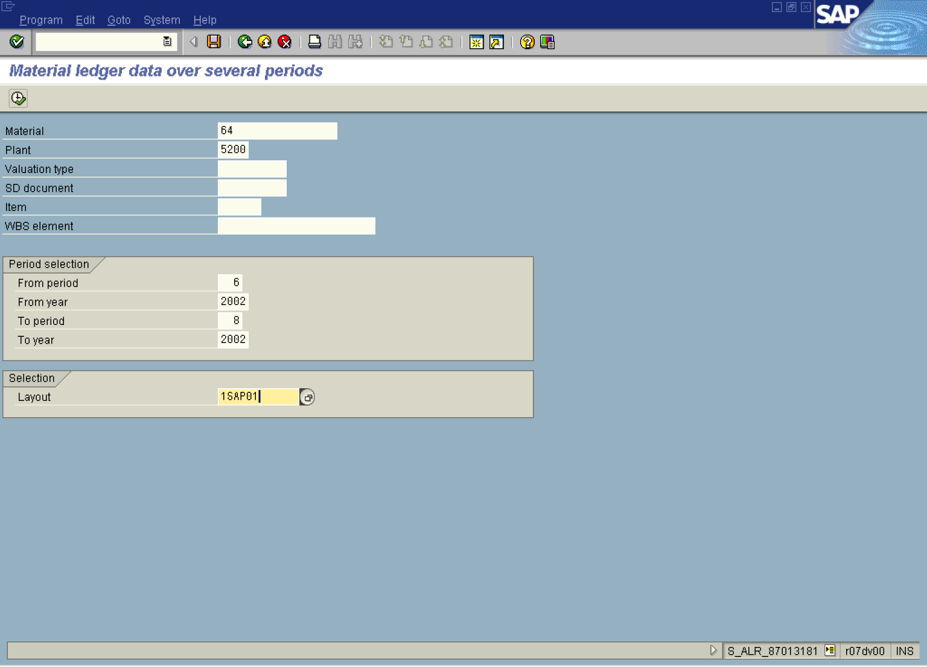

2. Update the following fields:

Field Name | Field Description | Values
Material | Code identifying a product or component | Example: 64
Plant | Code identifying the operational unit of the company where the material is manufactured and stored | Example: 5200
From period | Description of the From period. | Example: 1
From year | Description of the From year. | Example: 2002
To period | Description of the To period. | Example: 7
To year | Description of the To year. | Example: 2002

3. Click Layout .

Layout: Choose

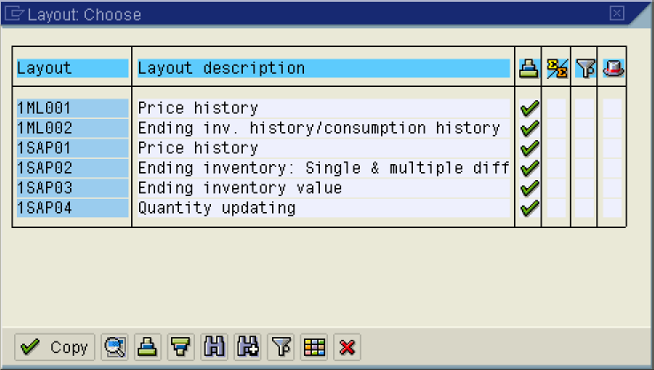

4. Click 1ML001 Button 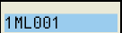.

Material ledger data over several periods

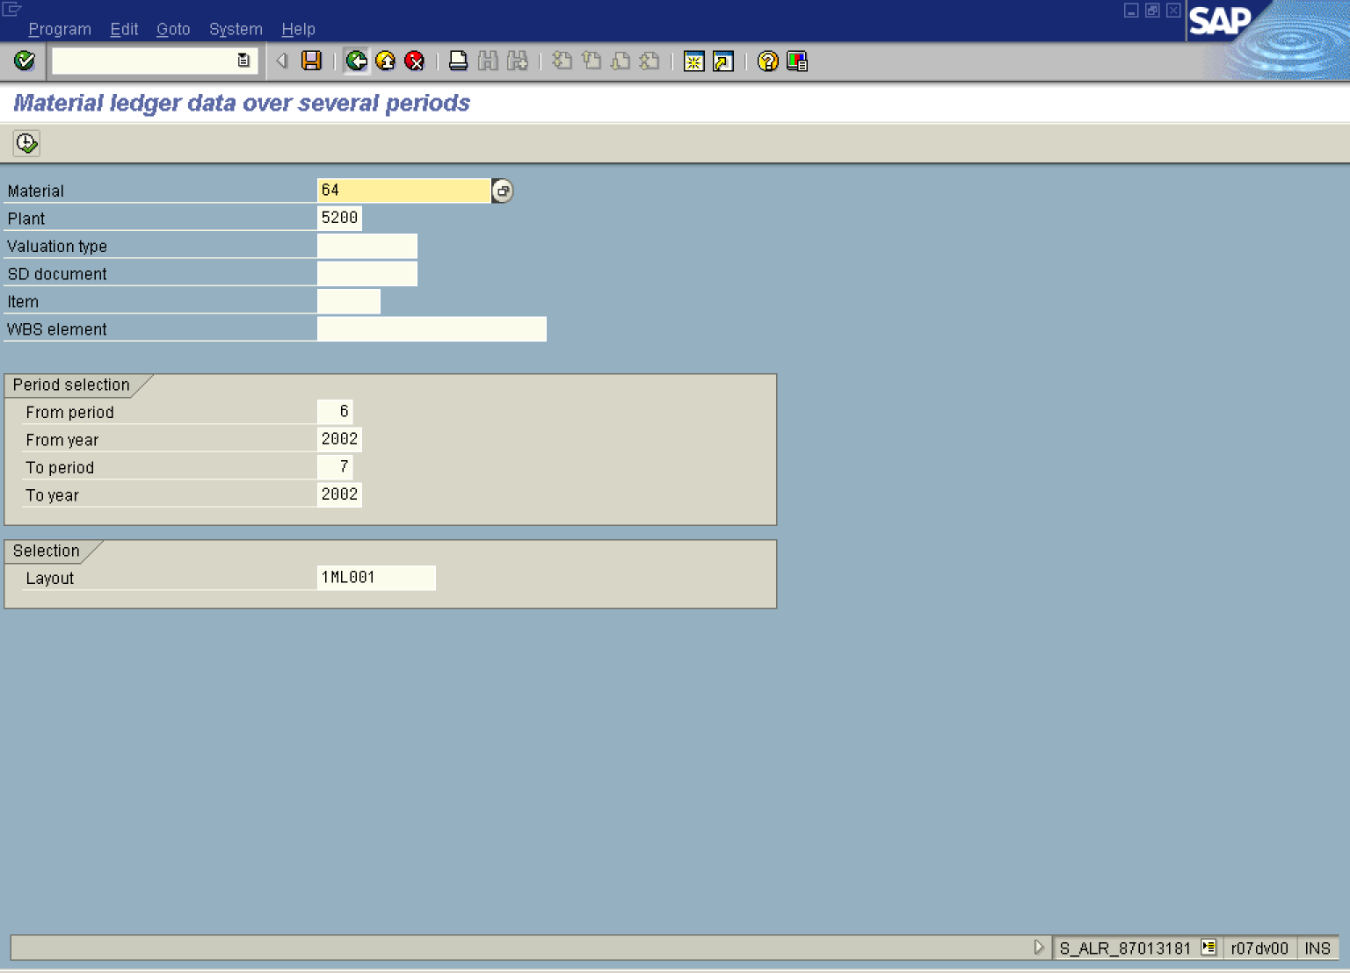

5. Click .

Material ledger data over several periods

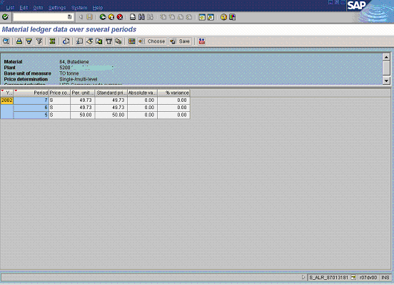

6. Click Back .

7. Click Back .

